Supporting a Forest School Programme: Practical Skills

Level 2- Workbook
(Modules 1 & 2)

Learner Name:

Training Venue:

Training Dates:

Return Address: | Postcode:
Statement of Ownership:

I hereby confirm the work contained in these pages is my own work, and I have referenced any pictures or photos appropriately.

Signed: Date:

Section A – To be completed after Module 1

Part 1 – Understand the terminology of risk assessment at Forest School

1.1a (AC: 4.1) Define what is meant by the term ‘hazard’ and give examples of hazards that may be present at Forest School.

1.1b (AC: 4.1) Define what is meant by the term ‘risk’ and give examples of risks that may be encountered at Forest School.

Part 2 – Be able to carry out practical tasks at Forest School

2.1 (AC:5.4) Demonstrate the tying of a range of knots used at Forest School – Practice the knots and lashings introduced this module. These will be assessed during module 2.

2.2 (AC:5.5) Safely make a range of craft items using woodland materials. Insert a photograph or diagram of 2 items you have made during the 1st Module of Forest School training and annotate them to name the materials and techniques used in the process.

1)

2)

Section B – To be completed after Module 2

Part 3 – Personal Protective Equipment

3.1a (AC:5.1) What is Personal Protective Equipment (PPE)? Describe its function, importance and give examples of PPE items.

3.1b (AC:5.1) How is the decision to wear PPE made within a Forest School programme?

3.2 (AC:5.1) Select appropriate PPE and clothing for a range of situations at Forest School. The table below lists 4 situations that may occur within a Forest School programme. Complete the righthand column to identify what sort of PPE or clothing may be required for these tasks.

Forest School Situation | Possible PPE to be used?
A.

It is winter and the weather is cold and raining. The Forest School session is 3 hours long.

B.

Conservation type activities – the group are involved with clearing areas and managing habitats. They are using tools to cut down small diameter trees, moving logs to build woodpiles, clearing brambles and other plants, using spades to plant trees etc

C.

To get to and from the Forest School site the group have to walk along a road. It is a quiet lane but does not have any pavements.

D.

Some individuals in the group are interested in campfire cooking, and started to experiment with recipes that involve using metal grills, pots and pans. They will need to move these items around safely whilst the fire is burning.

Part 4 – Safe Tool Practice

4.1. (AC: 5.2) Annotate the pictures below of a Fixed Blade Knife and Bow Saw to describe how you would check that the tool is fit for purpose.
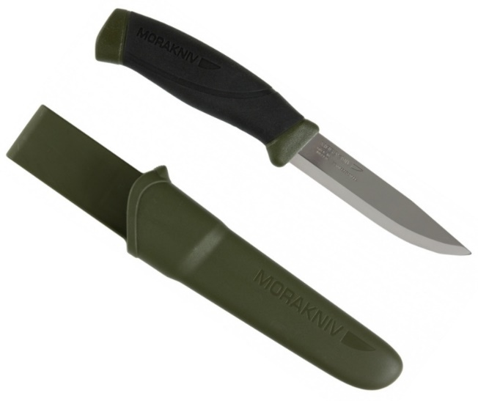
Handle & Tang -
Blade -
Sheath -
Sharpness -

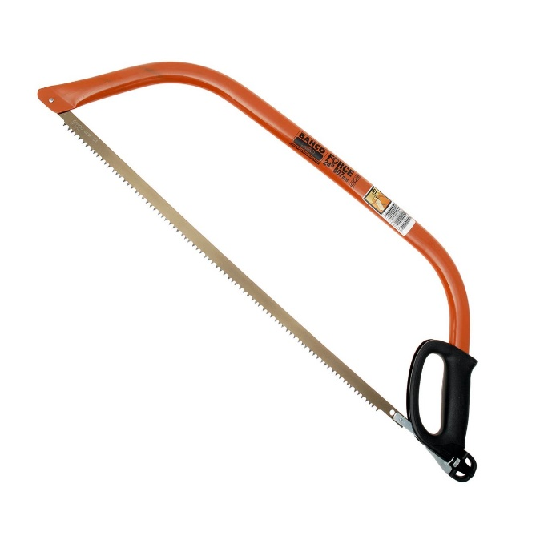
Blade attachment & Tensioning mechanism -
Frame -
Blade -
Hand guard & Blade Cover (not shown) -

4.2 (AC:5.3) Describe features of a ‘safe working area’ in regards to using tools at Forest School.

4.3 (AC:5.3) Annotate the picture below to outline how a tool user should be appropriately dressed.

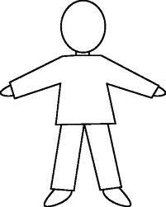
Hair & Head -
Scarves & Jewellery -
Hands -
Footwear -

4.4 (AC:5.3) Describe 3 important features that the tool user should consider when positioning their body (standing or sitting stances) when using tools at Forest School.

1.

2.

3.

4.5 (AC:5.2) Describe how to clean tools appropriately.

4.6 (AC:5.2) Describe how to store tools appropriately. Describe features of suitable permanent storage and temporary storage when transporting tools to, from and on site.

Part 5 – Making items using natural materials

5.1 (AC:5.5) Safely make a range of craft items using woodland materials. Insert a photograph or diagram of 2 items (different from the ones outlined in Part 2 (Module 1) above) you have made during the Forest School training and annotate them to name the materials and techniques used in the process. Please ensure at least one of the items was made using tools.

Name of item 1:
A. Annotated Photo/diagram:

Name of item 2:
A. Annotated Photo/diagram:

Part 6 – Shelter Building

6.1 (AC:5.6) Erect a temporary shelter using a tarpaulin or natural woodland materials. Insert a photograph/s or diagram/s of a shelter you have build during the Forest School training and annotate it to describe the resources used, techniques applied and the design created.

Part 7 – Fire Lighting and Management

7.1 (AC:5.7) Draw a diagram or insert a photograph of a safely situated fire area. Annotate the picture/photograph to describe features that need to be considered when deciding on where to site a fire.

Picture or Photo | Description of Features to consider
 | Overhead -
 | Vicinity to paths/seating/structures -
 | Ground layer & Soil -

7.2 (AC:5.7) Annotate the picture below to outline how people managing the fire (or cooking on it) should be appropriately dressed.

Hair -
Scarves & Jewellery -
Hands -
General Clothing -

7.3 (AC:5.7) Describe 3 safety guidelines about managing a fire (and the space around it) at Forest School.

1.

2.

3.

7.4 (AC:5.8) Explain how to safely extinguish a fire and leave the site safe.

8. Practical Skills Tutor Statement – Your tutor/s will be completing a Practical Skills Witness statement after observing your tool practice, knot tying and fire management on Module 2. Please include this assessment sheet with this workbook.

Section C – To be completed during assisting at a Forest School Programme

The Learning & Development Workbook explains about the process of supporting a Forest School programme in more detail.

Part 9 – Risk Assessment

9.1 (AC:4.2) Carry out a site risk assessment for the Forest School site. Insert an appropriate risk assessment document, this could be a daily risk assessment based on the Forest School leaders seasonal site risk assessment. You can use any appropriate risk assessment format but it must represent the 5 step process of risk assessment within it. If you wish to use the FSTC risk assessment format – blank forms can be downloaded from the student section of the FSTC website – www.forestschooltraining.co.uk

9.2 (AC:4.2) Carry out a risk-benefit assessment for an activity/task/experience at Forest School. Insert an appropriate risk benefit document. You can use any appropriate format but it must indicate benefits as well as risks (using the 5 step process) within it. If you wish to use the FSTC risk- benefit format – blank forms can be downloaded from the student section of the FSTC website – www.forestschooltraining.co.uk

Bibliography/References:

