# Forest School Workbook 1

|  |  |
| --- | --- |
| **Learner Name:** |  |
| **Training Venue:** |  |
| **Training Dates:** |  |
| **Return Address:** | **Postcode:** |
| **Statement of authenticity:**  I hereby confirm the work contained in these pages is my own work, and that I have referenced any quotes and images I have used appropriately.  Written signature: Date: | |

**1.1a** **Complete the mind map below describing types of evidence that could identify flora**.

**Flora**

**1.1b Complete the mind map below describing types of evidence that could identify fauna**.

**Fauna**

**1.1c** **Identify a range of local woodland flora and fauna for your own site and include four common species that are dangerous to humans.**

You need provide photographs or drawings (preferably your own) of a total of 12 species of flora and fauna (trees, ground flora, fauna). Please ensure you include 4 species potentially hazardous to humans and write about how these are hazardous. You will need to give **at least 3 ID traits** for each of the **species** (see example below).*(Attach additional pages as necessary)*

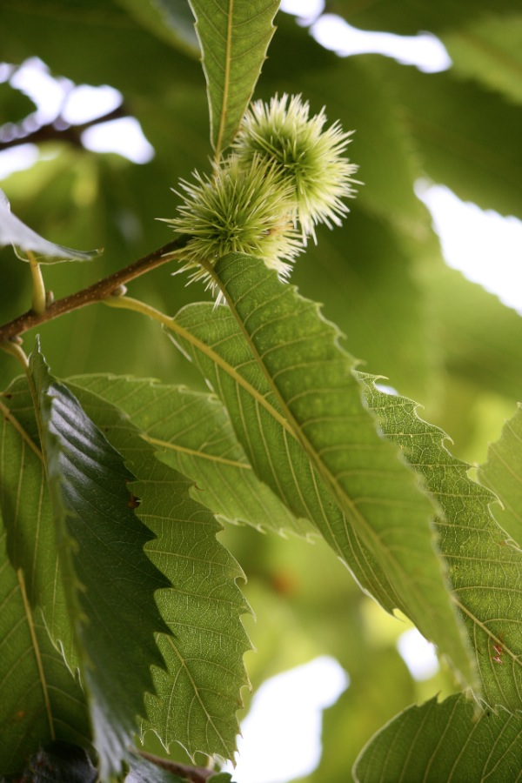

***Sweet Chestnut****, Photo taken by M. Shakespeare FSTC September 2010****.***

***Leaves****: long (16-28cm) narrow (5-9cm) individual leaves with a saw-tooth edge. (Good detailed description and sizes distinguish this from other similar leaves)*

***Bud****: round, reddish, alternate;*

***Fruit****: edible and encased in spiky green shells;*

***Bark****: when young is dark olive green colour and when mature has deep parallel fissures which begin to spiral in veteran trees*.

|  |
| --- |
|  |

**1.2a Draw the typical vertical and horizontal structure of broadleaved woodland, labelling the structures and labelling examples of species and non living feature within each.**

**1.2b Draw the typical vertical and horizontal structure of coniferous plantation woodland, labelling these structures and labelling examples of species and non living features within each**.

|  |
| --- |
|  |

**1.3 Outline how Forest School can harm the woodland and how that impact can be minimised. Use the form below for your answers.**

|  |  |
| --- | --- |
| **Woodland Impact** |  |
| **i)** | **Explanation (using examples)**  **How it can be minimised:** |
| **Woodland Impact** |  |
| **ii)** | **Explanation (using examples)**  **How it can be minimised:** |

|  |  |
| --- | --- |
| **Woodland Impact** |  |
| **iii)** | **Explanation (using examples)**  **How it can be minimised:** |
| **Woodland Impact** |  |
| **iv)** | **Explanation (using examples)**  **How it can be minimised:** |

**Managing Risk at Forest School**

|  |
| --- |
| **1.4a Define the terms hazard and risk.** |
| **1.4b What is Personal Protective Equipment (PPE)? Describe its function, importance and give examples of PPE items.**  **1.4c How is the decision to wear PPE made within a Forest School programme?** |

**1.5 Identify appropriate Personal Protective Equipment (PPE) for a range of tasks at Forest School. The table below lists 4 situations that may occur within a Forest School programme. Complete the right hand column to identify what sort of PPE may be required for these tasks.**

|  |  |
| --- | --- |
| **Forest School situation** | **Possible PPE to be used?** |
| 1. It is winter and the weather is cold and raining. The Forest School session is 3 hours |  |
| 1. Conservation type activities – the group are involved with clearing areas and managing habitats. They are using tools to cut down small diameter trees, moving logs to build woodpiles, clearing brambles and other plants, using spades to plant trees etc |  |
| 1. To get to and from the Forest School site the group have to walk along a road. It is a quiet lane but does not have any pavements. |  |
| 1. Some individuals in the group are interested in campfire cooking, and have started to experiment with recipes that involve using metal grills, pots and pans. They will need to move these items around safely whilst the fire is burning. |  |

**1.6a Carry out a Site Risk Assessment**

|  |  |
| --- | --- |
| **Venue:** | **Assessment Carried out by:** |
| **Postcode:** | **Signature: Date:** |
| **Location Grid Reference:** |

|  |  |  |  |  |
| --- | --- | --- | --- | --- |
| Areas to check (only check and tick those relevant to your site) | Hazards | **Risk** | **Control action** | **OK/not OK?** |
| **Access to the site**:   * Public rights of way * Roads * Parking |  |  |  |  |
| **Boundaries around the site**:   * Barbed wire * Streams * Ditches * Roads * Tracks |  |  |  |  |
| **Other people using the site**   * Rangers * Contractors * Walkers * Cyclists * Horse riders * Other children |  |  |  |  |

|  |  |  |  |  |
| --- | --- | --- | --- | --- |
| Areas to check | Hazards | **Risk** | **Control action** | **OK/Not OK** |
| **Canopy layer**   * Deadwood in overhead trees * Leaning, dead trees * Branches dying back * Branch dropping species |  |  |  |  |
| **Shrub layer**   * Deadwood in smaller trees * Leaning smaller tree * Poisonous/irritant species |  |  |  |  |
| **Field layer**   * Branches sticking out at eye level * Poisonous plants * Prickly plants |  |  |  |  |
| **Ground layer**   * Hidden logs lying in the grass * Broken glass, rubbish & rusty metal * Fungi * Dog faeces * Pond, stream, boggy areas * Slope, embankments * Holes in ground |  |  |  |  |

**1.6 b Carry out a risk–benefit assessment for an experience at FS that carries significant risk such as using tools, climbing trees or using ropes**

**Activity Risk Benefit Assessment**

|  |  |
| --- | --- |
| **Brief description of activity:** | **Completed By:**  **Date:** |
|
|
| **Benefits of Experience/Activity:** | |

|  |  |  |  |
| --- | --- | --- | --- |
| **Activity/Experience steps** | **Risk** | **Control Actions** | **OK/not OK?** |
|  |  |  |  |

**Forest School and Practical Skills**

**1.7** Annotate the pictures below of a **Fixed Blade Knife** and **Bow Saw** to describe how you would check that the tool is fit for purpose.

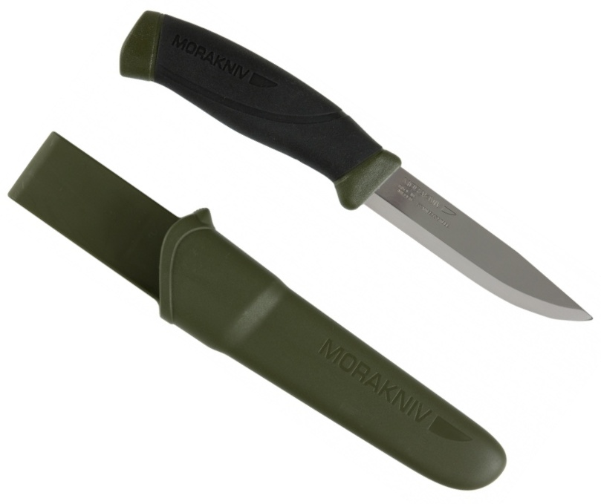

**Handle & Tang** -

**Blade** -

**Sheath** -

**Sharpness** -

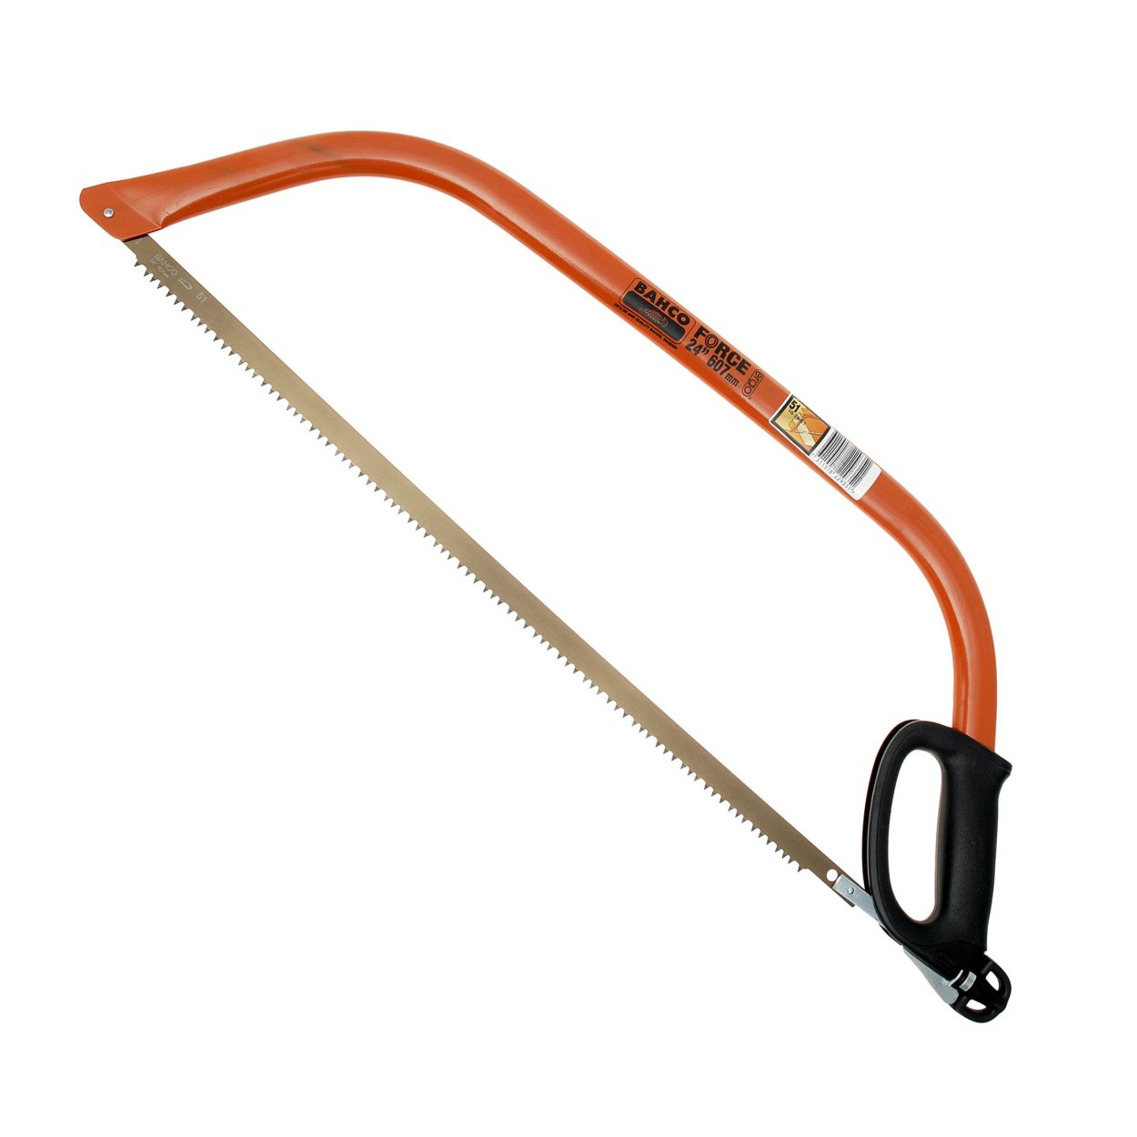

**Blade attachment & Tensioning mechanism** -

**Frame** -

**Blade** -

**Hand guard & Blade Cover (not shown)** -

**1.8 Annotate the pictures below to illustrate safe use of these tools.**

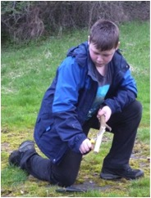

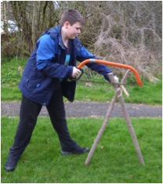

**Stance**

**Hand position**

**Stance**

**1.9 Comment on the knots you might use in these situations and say why**

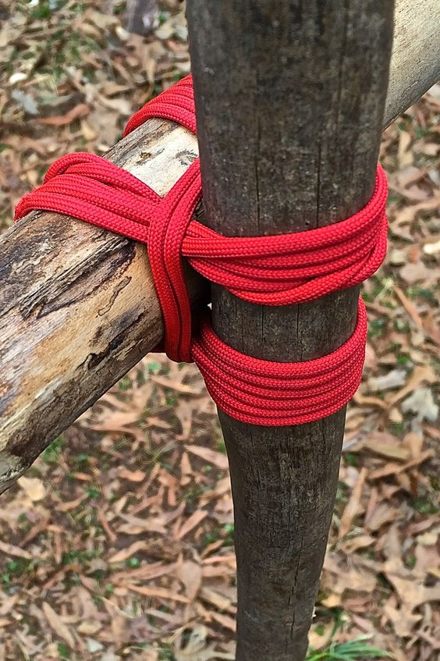

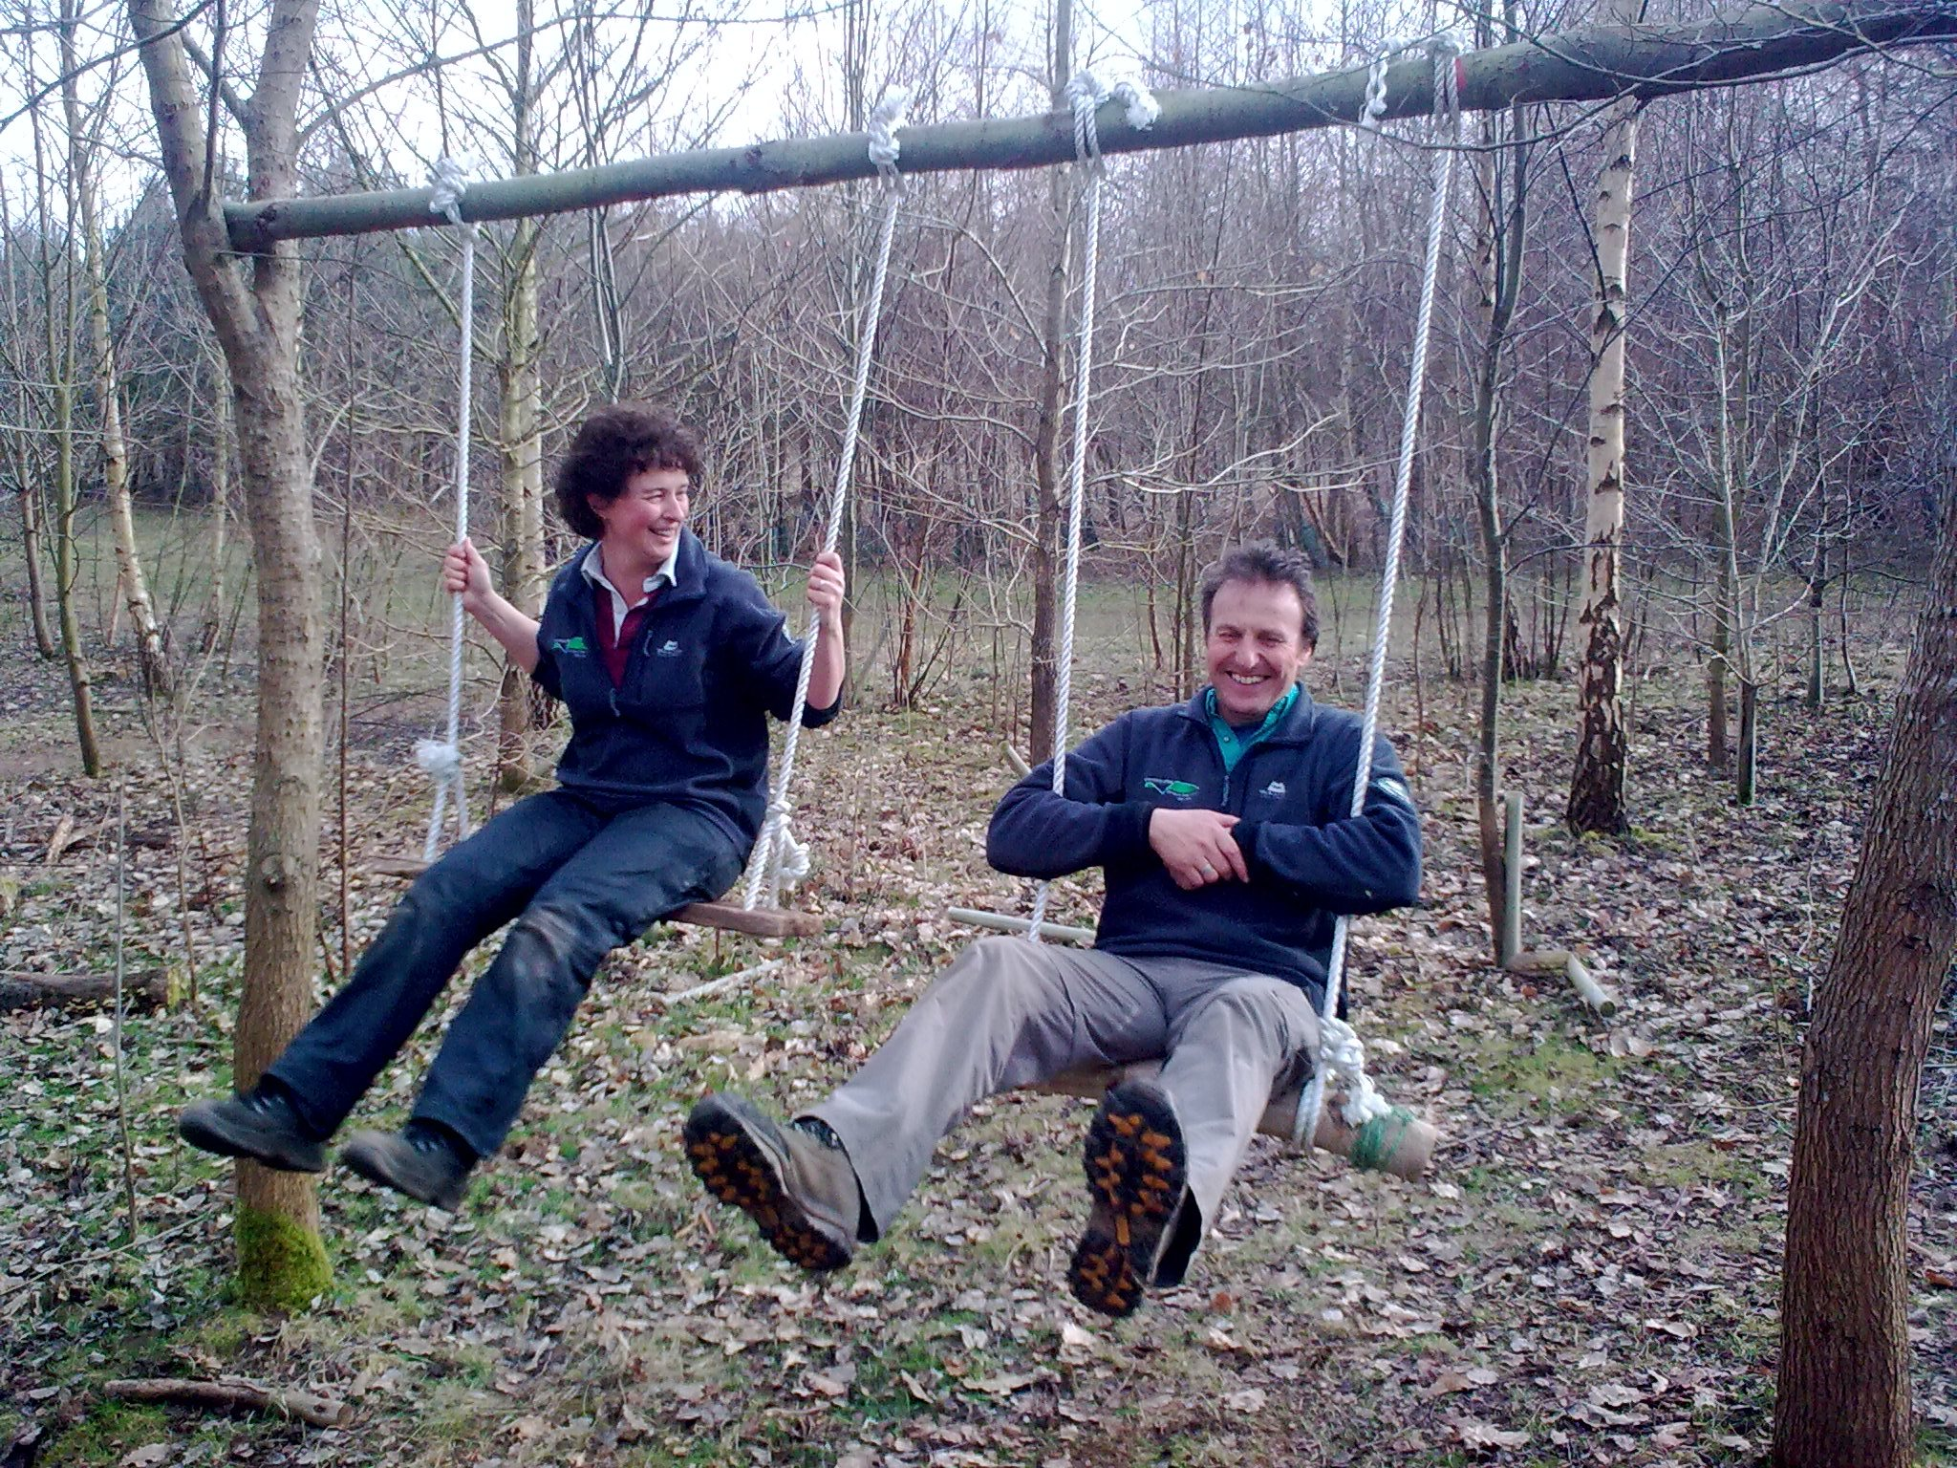

**Forest School Association**

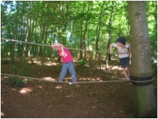

**1.10 Provide descriptions of how you made two items using natural materials during FS training and include steps you took to minimise the ecological impact of using the resources.**

|  |
| --- |
| **1.10a Annotated diagram/photo or written description of steps**  **How I minimised impact….** |

|  |
| --- |
| **1.10b annotated diagram/photo or written description of steps** |
| **How I minimised impact….** |

**1.11** Erect a temporary shelter using a tarpaulin and ropes. Insert a photograph/s or diagram/s of a shelter you have build during the Forest School training and annotate it to describe the resources used, techniques applied and the design created. Also write about the steps you took to minimise the ecological impact.

|  |
| --- |
| **Description of shelter built**  **How I minimised the impact ...** |

|  |  |
| --- | --- |
| **Picture or Photo** | **Description of Features to consider** |
| **Safety Equipment –** |
| **Overhead -** |
| **Vicinity to paths/seating/structures -** |
| **Ground layer & Soil -** |

**1.12 a Draw a diagram or insert a photograph of a safely situated fire area. Annotate the picture/photograph to describe features that need to be considered when deciding on where to site a fire.**

**1.12b Annotate the picture below to outline how people managing the fire (or cooking on it) should be appropriately dressed.**

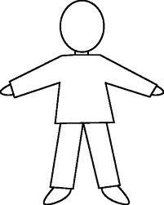

**Hair** -

**Scarves & Jewellery** -

**Hands** -

**General Clothing** -

1.12c Describe how you would safely extinguish a fire.

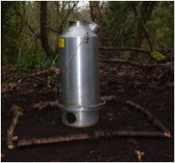

**1.13 Annotate the pictures below to illustrate safe use of a Kelly Kettle**

**Spout**

**Handle**

**Fire Surround**

**Fire Bowl**

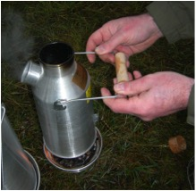

**Cork**

**Why is the kettle lifted on and off like this?**

[**http://www.kellykettle.com/faq?limit=all**](http://www.kellykettle.com/faq?limit=all)

**1.14 Demonstrate how to check that the Forest School site is left in an appropriate state.**

List four checks to be made at the end of each Forest School session.

|  |  |
| --- | --- |
|  | **Check to be made** |
| **1** |  |
| **2** |  |
| **3** |  |
| **4** |  |

**Supporting Learning & Development at Forest School**

The questions in this section are assignment based. You will need to complete your answers on separate paper or type them in here. Please make sure you refer to Guidance on Standard of Work Required before attempting your answers.

**1.15 Summarise the Forest School approach to learning mentioning how it differs from other forms of outdoor learning.**

**1.16 Outline the main features of Holistic Development, making reference to one theorist.**

**1.17 Give examples of how Holistic Development can be supported at Forest School, making sure to mention a rounded selection of areas of development.**

**1.18a Describe the key elements of play with reference to playwork principles, including freely chosen, intrinsically motivated and self directed.**

**1.18b Describe three methods you might use to promote play at Forest School**

**1.19 Describe 3 ways of encouraging behaviour that is appropriate at Forest School.**

**1.20a Describe a model of self esteem, making reference to at least one theory.**

**1.20b Explain 3 methods which may be used at Forest School to promote self esteem.**

**Bibliography – please include a bibliography detailing the reading and research you have done for this unit. Where you have used quotes please reference the source clearly.**